# The purpose of canners

The purpose of water bathing or steaming the cans is to annihilate any dangerous pathogens found in the food objects. Common bacteria such as Escherichia coli O157:H7, Salmonella enterica, Listeria monocytogenes and other pathogenic bacteria might be present in the product and can easily thrive in watery conditions. Even in acidic conditions some microorganisms can thrive which is why water bathing is essential for canning. Oxygen is also driven out of the cans which can help further kill microorganisms as they are aerobic organisms.

Water bath canner is used for acidic foods like tomatoes, pickles, jams, chutneys and other acidic food items with added acid.

Water bath canner, pressure canner left to right

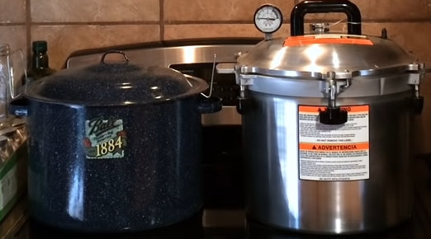

As high-PH foods cannot be water bathed, they must be pressure canned. Else it will cause complications from consuming wrongly preserved foods. The reason for this is that bacteria that grows from low-acid foods die at temperatures of 115 degrees Celsius or 240 degrees Fahrenheit. The water bath canner cannot reach that temperature as it has been tested that the jars can never exceed 100 degrees Celsius. Hence pressure canners must be used to can low acid foods safely.

Pressure canners are used to can low acid foods such as potatoes, meats, green beans. Sometimes there are a variety of hybrid equipment so that it can be used to can both acidic and alkaline foods. Generally alkaline foods need to be preserved with citric acid or any solvent that is highly acidic to be canned safely.

Electric canners are not approved by the NCHP or USDA but there have been instances where electric canning may have been considered convenient regardless of the food authority’s reticence on using these versatile cookers. Ultimately, the testing done on the electric multi-purpose canners are not fully developed or that they provide unreliable results for canners, causing wastage of food.

Oven canners

# Jars

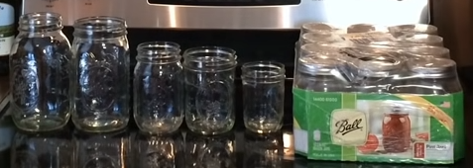

Low quality store-bought jars come from China and using other low-quality contaminated containers can hamper the progress of preserving food. Reliable mason jar manufacturers such as Ball or Kerr have been proven by the USDA for usage in regular and effective canning.

Other tools for canning

Lid grabber, can grabber, measurement ruler, funnels

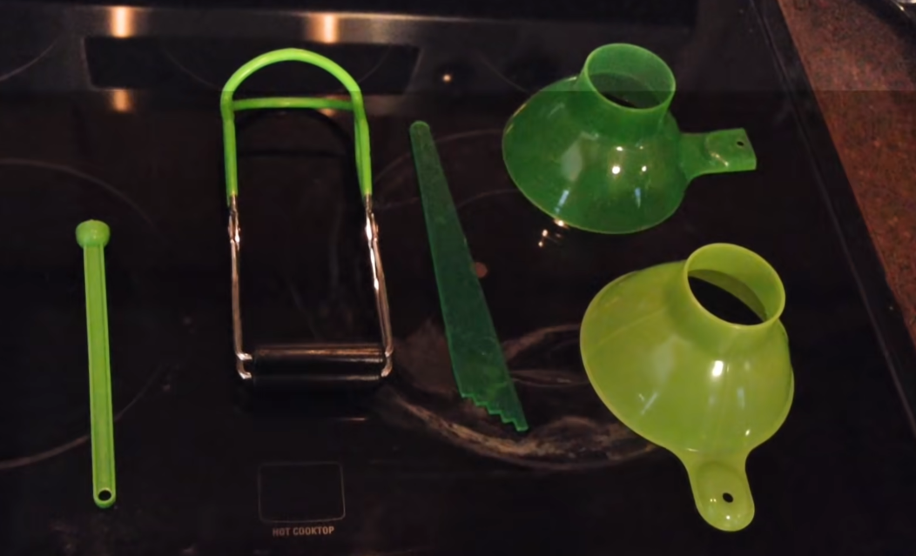

These tools are used to handle the cans without harm from the canner as the main issue with handling the cans are the high temperatures of the cans causing burns.

# List of mistakes

## Canning

* Not having enough right tools for canning

Having the right tools for canning is a great way for beginners to learn the basics of safety procedures and to enjoy the process of canning without harm. Ultimately, it is better for beginners to purchase enough tools for effective measures in all types of canning.



* Using bad quality jars

Jars can make or break the process of canning. It can be said that wastage is a big factor in preserving foods. Picking certified jar brands can ensure that wastage can be less when storing foods. Kerr or Ball are often sought-after by all types of enthusiasts for their robust and trustworthy products.

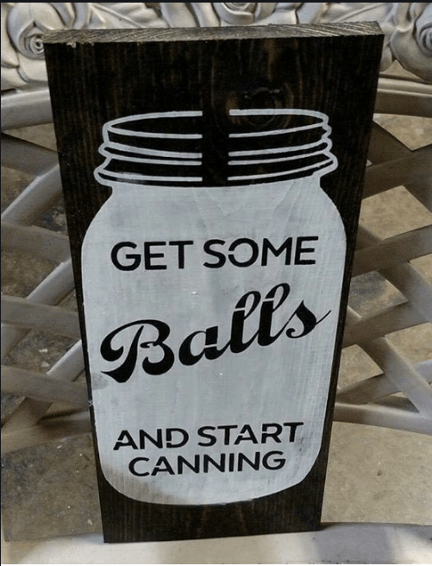

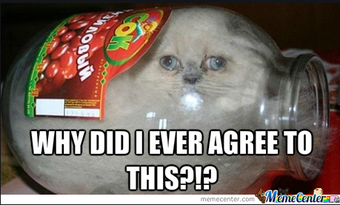

* Using an electric pressure canner

<https://nchfp.uga.edu/publications/nchfp/factsheets/electric_cookers.html>

An electric pressure canner sounds like an amazing idea when starting out as a canner. However, the USDA has warned against electric pressure canners when creating home-canned low-acid food because of their known dangers of increasing the risk of botulism. This is the case when environments with little oxygen can encourage the growth of bacteria often found in low acid foods. The tight space or vacuum of the pressure cooker can be an issue for pressure canning due to the high risk of botulism. Furthermore, the variables pressure and heat distribution determine the temperature of the cans. The process times also include the cool-down. Electric pressure canners can shorten the duration of cooldown which can make the food under-processed. Electric canners do display the value of the temperature but the accuracy of the appliance is always questioned. High-end pressure canners may try to solve these issues, but the risk of botulism is still high. Use electric pressure canners with caution.

* Not taking the elevation of location into account when pressure canning

Pressure is proportional to the elevation of the location when pressure canning. If the canner follows the standards of pressure canning it becomes clear that heat distribution becomes more difficult at higher altitudes. One of the best reference charts on pressure canning can be found on the NCHP homepage.

* Not having enough pressure in pressure canning

Pressure ensures good heat distribution so that microorganisms can be thoroughly killed during canning. Low-acid foods need to be canned properly to reduce the risk of botulism.

* Failing to measure temperature or the time accurately

Measurements can be inaccurate if the canner does not regularly measure the temperature during canning. Unseen factors such as the stove turning off or the canning not having enough heat distribution or time is important to address especially for beginners.

# Setup

The simplest procedures of preservation involve canning and two procedures are provided, each

Water-bathing

Warning: make sure to read the instructions or manual that comes with the water bath canner for there mgith be slight variations that might affect your own procedure of canning.

Tools:

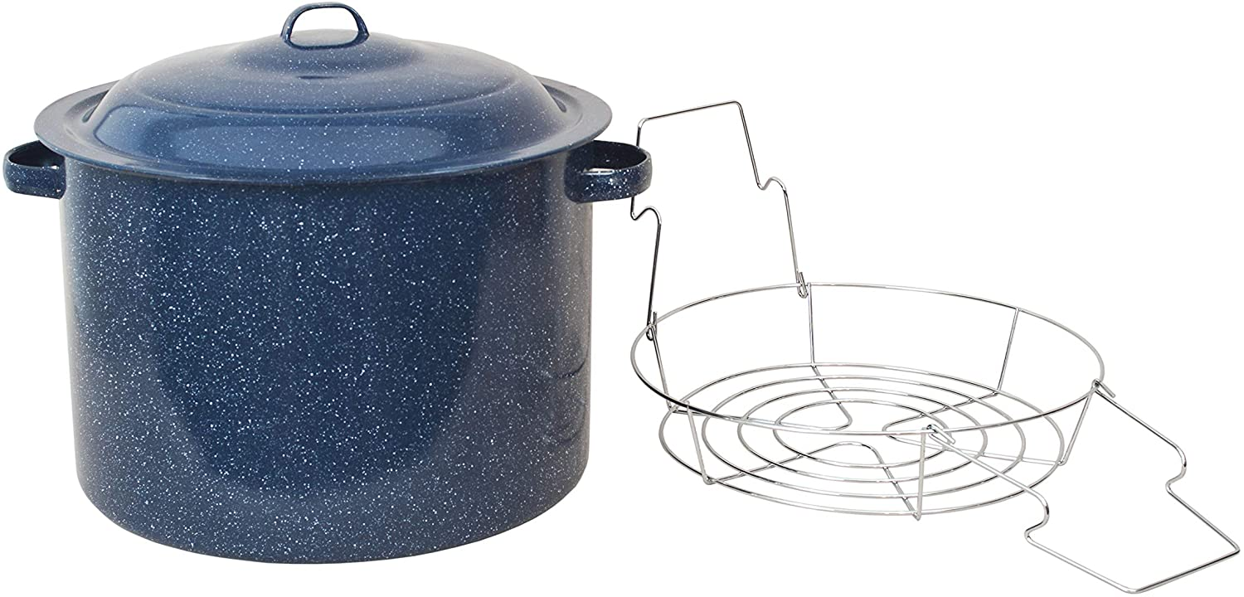

Source: <https://nchfp.uga.edu/publications/uga/using_bw_canners.html>

|  |  |  |
| --- | --- | --- |
|  | 1. | Before you start preparing your food, place canner rack in the bottom of a boiling water canner.  Fill the canner half full with clean warm water for a canner load of pint jars. For other sizes and numbers of jars, you will need to adjust the amount of water so it will be 1 to 2 inches over the top of the filled jars. |
|  | 2. | Center the canner over the burner and preheat the water to 140 degrees F. for raw-packed foods and to 180 degrees F. for hot-packed foods. You can begin preparing food for your jars while this water is preheating. |
|  | 3. | Load filled jars, fitted with lids and ring bands, into the canner one at a time, using a jar lifter. When moving jars with a jar lifter, make sure the jar lifter is securely positioned below the neck of the jar (below the ring band of the lid). Keep the jar upright at all times. Tilting the jar could cause food to spill into the sealing area of the lid.  If you have a shaped wire rack that has handles to hold it on the canner sides, above the water in the canner, you can load jars onto the rack in the raised position and then use the handles to lower the rack with jars into the water. |
|  | 4. | Add more boiling water, if needed, so the water level is at least one inch above the jar tops. Pour the water around the jars and not directly onto them. For process times over 30 minutes, the water level should be 2 inches above the jars. |
|  | 5. | Turn the heat setting to its highest position, cover the canner with its lid and heat until the water boils vigorously. |
|  | 6. | Set a timer (after the water is boiling) for the total minutes required for processing the food. |
|  | 7. | Keep the canner covered for the process time. The heat setting may be lowered as long as a gentle but complete boil is maintained for the entire process time. |
|  | 8. | Add more *boiling* water during the process, if needed, to keep the water level above the jar tops. Pour the water around the jars and not directly onto them. |
|  | 9. | If the water stops boiling at any time during the process, turn the heat on its highest setting, bring the water back to a vigorous boil, and begin the timing of the process over, from the beginning (using the total original process time). |
|  | 10. | When the jars have been processed in boiling water for the recommended time, turn off the heat and remove the canner lid. Wait 5 minutes before removing jars to allow the canner contents to settle. This waiting period is not required for safety of the food when using USDA or University of Georgia processing times, however. |
|  | 11. | Using a jar lifter, remove the jars one at a time, being careful not to tilt the jars. Carefully place them directly onto a towel or cake cooling rack, leaving at least one inch of space between the jars during cooling. Avoid placing the jars on a cold surface or in a cold draft. |
|  | 12. | Let the jars sit undisturbed while they cool, from 12 to 24 hours. Do *not* tighten ring bands on the lids or push down on the center of the flat metal lid until the jar is completely cooled. |
|  | 13. | Remove ring bands from sealed jars. Put any unsealed jars in the refrigerator and use first. |
|  | 14. | Wash jars and lids to remove all residues. |
|  | 15. | Label jars and store in a cool, dry place out of direct light. |

Pressure canning

Source: <https://nchfp.uga.edu/publications/uga/using_press_canners.html>

Procedure

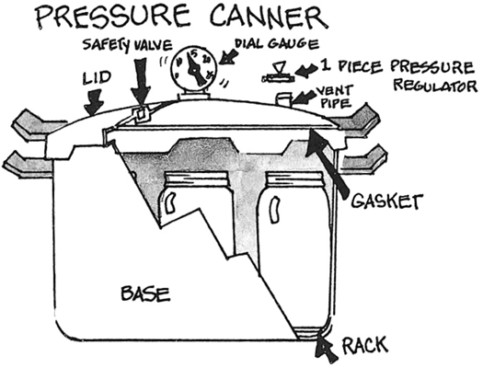

1. Make sure the pressure canner is working properly before preparing food. Clean lid gaskets and other parts according to the manufacturer’s directions; make sure all vent pipes are clear and contain no trapped material or mineral deposits. Center the canner over the burner. The burner and range must be level. Your pressure canner can be damaged if the burner puts out too much heat. In general, do not use on an outdoor LP gas burner or gas range burner over 12,000 BTU’s. Check your manufacturer’s directions for more information about appropriate burners.
2. Put the rack and hot water into the canner. If the amount of water is not specified with a given food, use enough water so it is 2 to 3 inches high in the canner. Longer processes required more water. Some specific products (for example, smoked fish) require that you start with even more water in the canner. Always follow the directions with USDA processes for specific foods if they require more water be added to the canner.
3. For hot packed foods, you can bring the water to 180 degrees F. ahead of time but be careful not to boil the water or heat it long enough for the depth to decrease. For raw packed foods, the water should only be brought to 140 degrees F.
4. Place filled jars, fitted with lids and ring bands, on the jar rack in the canner, using a jar lifter. When moving jars with a jar lifter, make sure the jar lifter is securely positioned below the neck of the jar (below the ring band of the lid). Keep the jar upright at all times. Tilting the jar could cause food to spill into the sealing area of the lid.
5. Fasten the canner lid securely. Leave the weight off the vent pipe or open the petcock.
6. Turn the heat setting to its highest position. Heat until the water boils and steam flows freely in a funnel-shape from the open vent pipe or petcock. While maintaining the high heat setting, let the steam flow (exhaust) continuously for 10 minutes.
7. After this venting, or exhausting, of the canner, place the counterweight or weighted gauge on the vent pipe, or close the petcock. The canner will pressurize during the next 3 to 10 minutes.
8. Start timing the process when the pressure reading on the dial gauge indicates that the recommended pressure has been reached, or, for canners without dial gauges, when the weighted gauge begins to jiggle or rock as the manufacturer describes.
9. Regulate the heat under the canner to maintain a steady pressure at, or slightly above, the correct gauge pressure. One type of weighted gauge should jiggle a certain number of times per minute, while another type should rock slowly throughout the process – check the manufacturer’s directions.
10. Loss of pressure at any time can result in underprocessing, or unsafe food.
11. Quick and large pressure variations during processing may cause unnecessary liquid losses from jars.

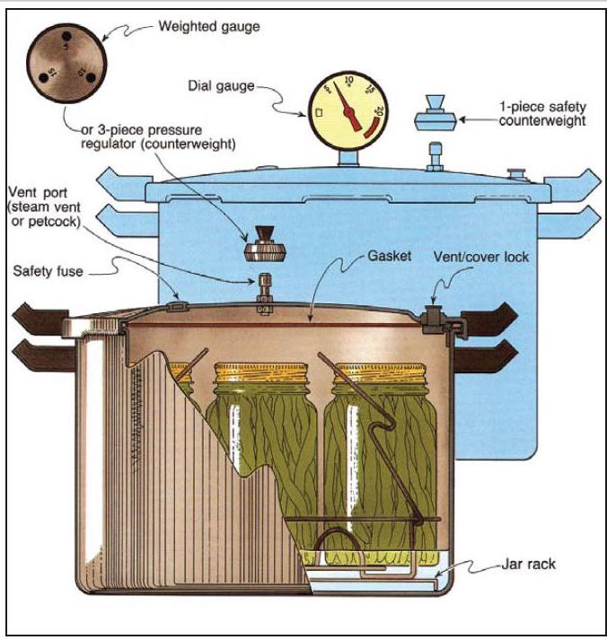  
**IMPORTANT:** If at any time pressure goes below the recommended amount, bring the canner back to pressure and begin the timing of the process over, from the beginning (using the total original process time). This is important for the safety of the food.

1. When the timed process is completed, turn off the heat, remove the canner from the heat (electric burner) if possible, and let the canner cool down naturally. (Lift the canner to move it; do not slide the canner. It is also okay to leave the canner in place after you have turned off the burner. It is better to do so than to let jars inside the canner tilt or tip over if the canner is too heavy to move easily.)

A6Q1-part1.py

1. While the canner is cooling, it is also de-pressurizing. Do not force cool the canner. Forced cooling may result in food spoilage. Cooling the canner with cold running water or opening the vent pipe before the canner is fully depressurized are types of forced cooling. They will also cause loss of liquid from jars and seal failures. Forced cooling may also warp the canner lid.
2. Even after a dial gauge canner has cooled until the dial reads zero pounds pressure, be cautious in removing the weight from the vent pipe. Tilt the weight slightly to make sure no steam escapes before pulling it all the way off. Newer canners will also have a cover lock in the lid or handle that must release after cooling before the lids are twisted off. Do not force the lid open if the cover locks are not released. Manufacturers will provide more detailed instructions for particular models.
3. Depressurization of older canner models without dial gauges should be timed. Standard size heavy-walled canners require about 30 minutes when loaded with pints and 45 minutes when loaded with quarts. Newer thin-walled canners cool more rapidly and are equipped with vent locks that are designed to open when the pressure is gone. These canners are depressurized when the piston in the vent lock drops to a normal position. Some of these locks are hidden in handles and cannot be seen; however, the lid will not turn open until the lock is released.
4. After the canner is completely depressurized, remove the weight from the vent pipe or open the petcock. Wait 10 minutes; then unfasten the lid and remove it carefully. Lift the lid with the underside away from you so that the steam coming out of the canner does not burn your face.
5. Using a jar lifter, remove the jars one at a time, being careful not to tilt the jars. Carefully place them directly onto a towel or cake cooling rack, leaving at least one inch of space between the jars during cooling. Avoid placing the jars on a cold surface or in a cold draft.
6. Let the jars sit undisturbed while they cool, from 12 to 24 hours. Do *not* tighten ring bands on the lids or push down on the center of the flat metal lid until the jar is completely cooled.
7. Remove ring bands from sealed jars. Ring bands can be washed and dried and put away for using another time. Put any unsealed jars in the refrigerator and use first.
8. Wash jars and lids to remove all residues.
9. Label jars and store in a cool, dry place out of direct light.
10. Dry the canner, lid and gasket. Take off removable petcocks and safety valves; wash and dry thoroughly. Follow maintenance and storage instructions that come from your canner manufacturer.